|  |
| --- |
| **Kitchen Story**  **(Application Screenshot)** |

**Version History:**

|  |  |
| --- | --- |
| Author | Jaydeep Kumar Mandal |
| Purpose | Screenshot of the application |
| Date | 18th February 2023 |
| Version | 1.0 |

Contents

1. Homepage 3

2. Login Page 4

3. Registration Page 5

4. Admin Dashboard 6

5. Add Product 7

6. Search Result 8

7. Empty Cart 9

8. Cart 10

9. Checkout 11

10. Confirmation Page 12

1. Homepage

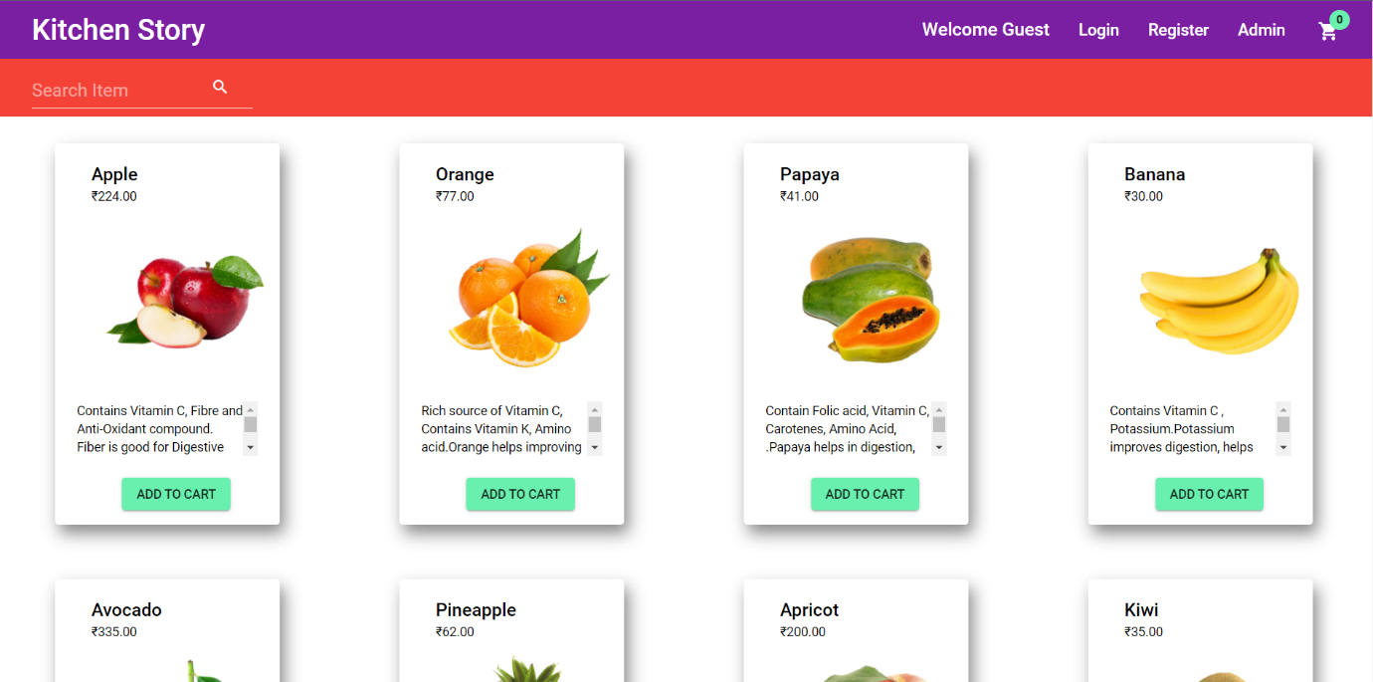

1. Login Page

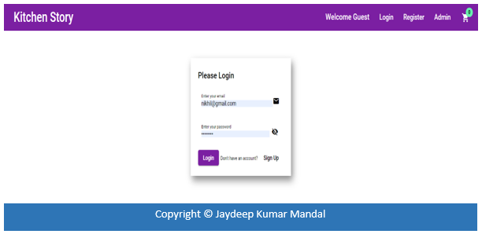

1. Registration Page

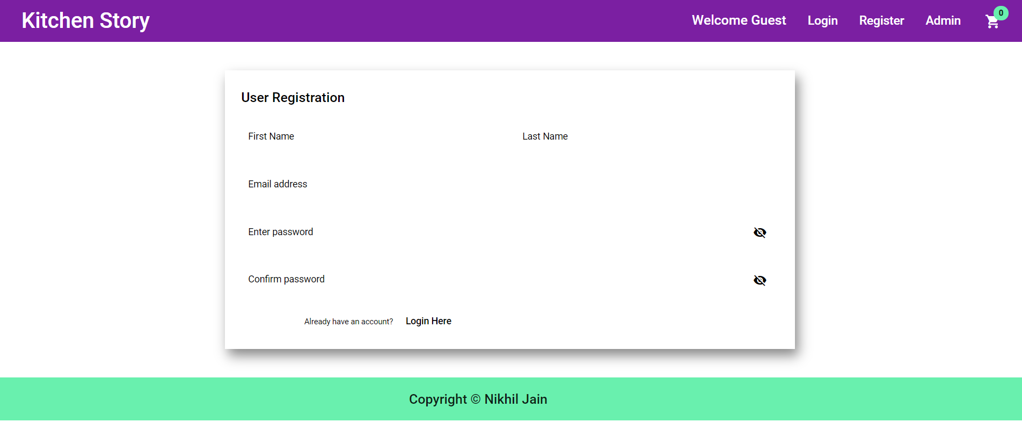

Copyright © Jaydeep Kumar Mandal

Copyright © Jaydeep Kumar Mandal

1. Admin Dashboard

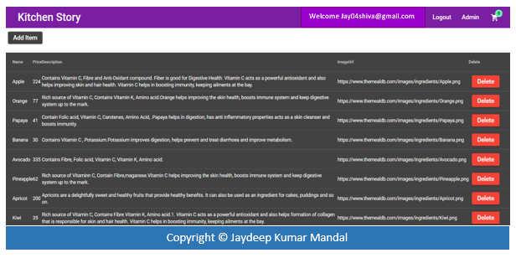

1. Add Product

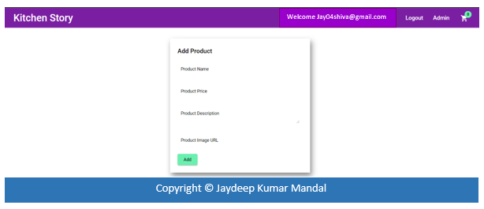

1. Search Result

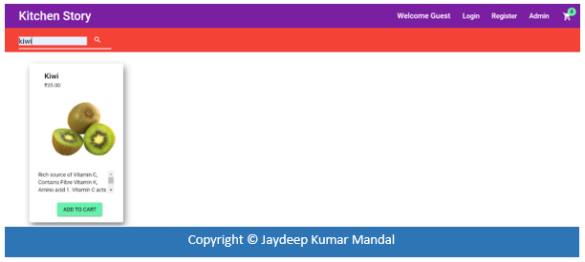

1. Empty Cart

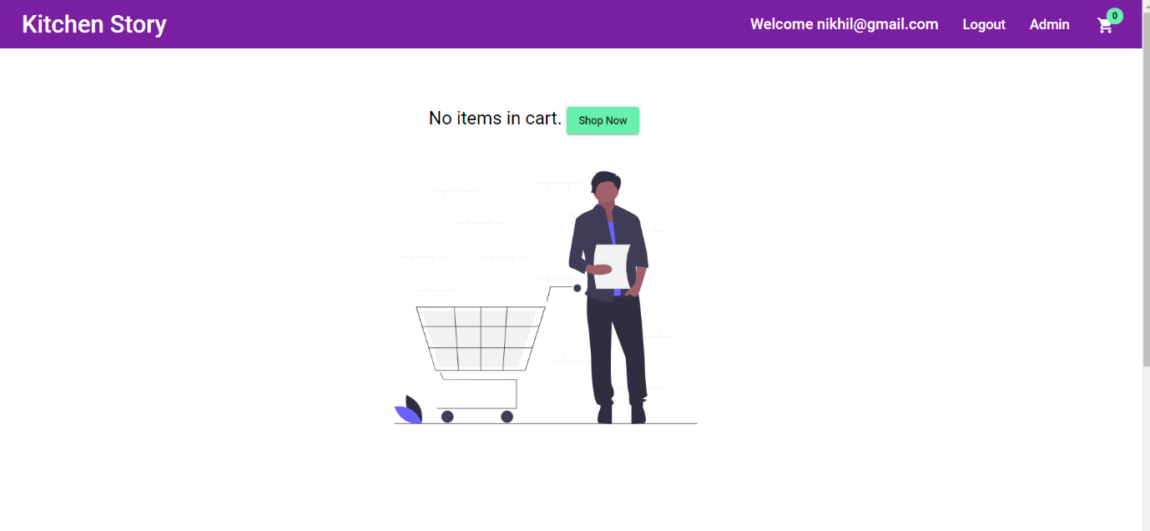

Welcome Jay04shiva@gmail.com

1. Cart

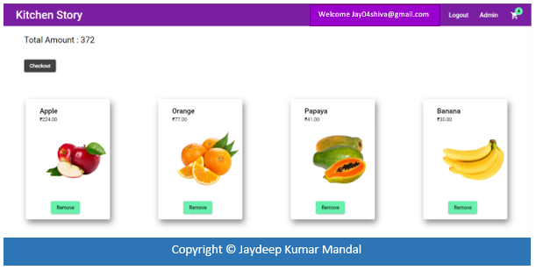

1. Checkout

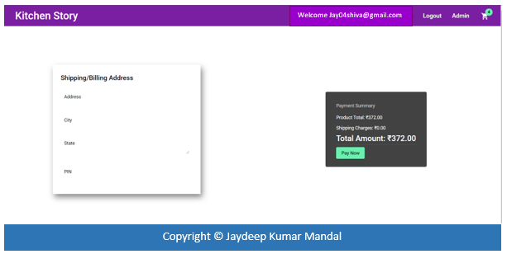

1. Confirmation Page

